VOLUNTEER HANDBOOK

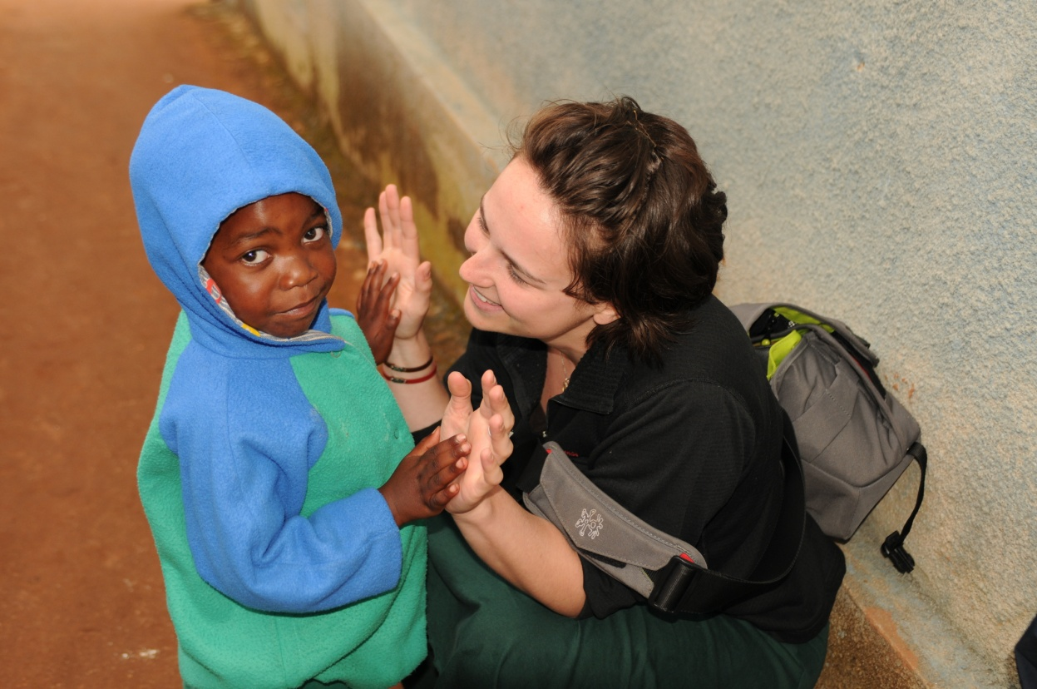

VOLUNTEER MISSION STATEMENT:
- The project area contains 16 villages with a population of 30,000 in a 15 mile radius
- 35% of villagers have HIV/AIDS
- Farmers in the village live on an income of $20month – 90% of villagers are farmers
- At Igoda primary school over 40% of children have lost at least one parent
- 71 orphans live in the children’s village – from 2 weeks old to 17 years old

Village Statistics

HIV/AIDS Statistics

In the spirit of Foxes’ Community and Wildlife Conservation Trust, volunteers shall strive to better communities through their willingness to participate in alleviating poverty and inequality.
This shall be accomplished in an environmentally harmonious manner through healthcare, civic agency and environmental education.
- In Tanzania: 1 in 12 people are infected; in Mufindi: 1 in 3 people are
- 1,400 children worldwide die every day from HIV/AIDS
- 700,000 children are born infected every year in Africa
- 26 million people have already died of AIDS worldwide, 95% of them in developing countries
- 28 million people in Africa have HIV/AIDS – every single day 5,500 people die

TABLE OF CONTENTS:

ORGANIZATIONAL & CULTURAL RULES………………………..4
VOLUNTEER OPTIONS………………………………………………..5
VOLUNTEER COST & HOW TO PAY……………………….……….6
USEFUL SWAHILI WORDS & PHRASES………………….……….7
TRANSPORTATION TO & FROM…………………………….………8
FOOD HOUSING………………………………………………….……..9
HEALTH, MEDICAL & PERSONAL SAFETY…………….……9-10
WHAT TO PACK………………………………………………………..10
VOLUNTEER STORIES……………………………………………….11
SAFARI OPTION………………………………………………………..12
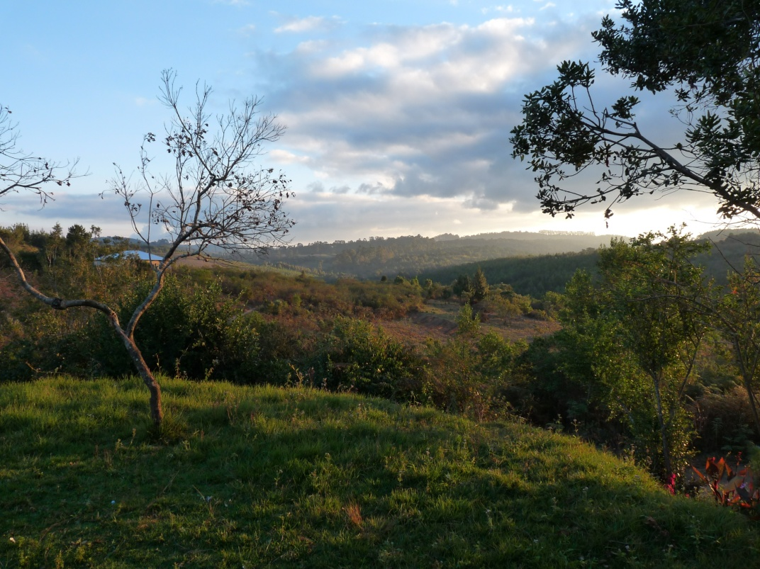

ORIENTATION
Welcoming volunteers into our NGO family is always a joy! A short orientation will be held upon arrival. This orientation will include a short tour, a review of our Behavior Contract, Acceptable Internet Usage Policy, our Health/Safety Information, and our Volunteer Agreement Contract. This is the time where we will go over rules, expectations of service, and address any questions or concerns. During this meeting, an initial work plan and schedule will be drawn up which will be reviewed after a few days of work. Please come prepared to pay a CASH key deposit of 150,000 Tsh for the property deposit and the key deposit. This deposit will be returned upon check out once the room key is returned and the room inspection is performed.

EXPECTATIONS OF SERVICE
We believe the work we do is meaningful, purposeful, and powerful, and we hope our volunteers will find the same to be true. Over time, we have seen that our happiest volunteers are the ones who arrive having mentally prepared themselves. Please consider some of the following questions: What does service mean you? What can you offer the organization? What is difference between service and charity? How will you know your work here was successful? Volunteers that arrive having considered how they want to spend their time, tend to get more out of the work they do.
Volunteers should also be aware that not all assigned tasks will be equally exciting or fun. You may be asked to wash dishes, sweep a floor, change a diaper etc. We have many projects working simultaneously and do our best to place volunteers based on their experience and preference. In order to do that, we ask volunteers to consider their own personal skill sets and where they think they will do their best work. We encourage you to come with a written list of expectations, goals, and work preferences to be discussed upon arrival.
It is also important to keep in mind that we hold our volunteers to the same standards as our employees. Volunteers will be expected to work 6 days a week for 8 hours per day. Each week, volunteers will meet with the Volunteer Coordinator to draw up a work plan and schedule. Volunteers are expected to arrive on time to their work site and to stay for the entirety of their shift. We try to accommodate most volunteer schedules when drawing up the weekly work plan. Volunteers may request a morning and afternoon shift with evenings off, an afternoon and evening shift with mornings off, or any combination as long as it equals 8 hours of total work time. However, most work in the village begins at 7:30 am and we encourage volunteers to begin their day at that time as well.
Below you will find an example of a typical volunteer work schedule!
7:30am | Report to Montessori School for Teacher’s Prep Meeting
8:00 am | Begin School Day- work one-on-one with students
12:30pm | End School Day
12:30pm | Lunch
1:30pm | Report to Administration Building for Office Work (organization of files and reports)
4:30pm | End Work Day

This is an example schedule of a medical/doctor volunteer!
7:30am | Meet at Medical Container to sort donated medical supplies
9:00am | Meet the lori (truck) to load up medical supplies to take to the Care and Treatment Center (clinic)
10:00am | Arrive at the clinic to unload supplies and meet with patients
4:00 pm | Leave clinic and head back to Children’s Village
5:00pm | Meet with on-site physician to examine critical cases at the Children’s Village
6:00pm | Meet with Jenny for updates on critical cases

CULTURAL RULES
Dress
Clothing is an important part of any culture. Just as there is appropriate and inappropriate clothing for any environment, the same holds true for the work you will be doing. We ask all of our volunteers to do their best to follow cultural norms of dress. Women are held to high standards with regards to modesty. This means that shoulders and legs (at least covering the knee), should be covered at all times. Absolutely no shorts, short dresses, low-cut shirts, spaghetti straps, tank tops, halter/tube tops, short skirts etc. An everyday outfit for a woman in the village would consist of a long skirt and a t-shirt/long sleeve shirt, with a light jacket if needed. Long pants are also fine as long as they are not form-fitting. Leggings are ok, if worn under a long skirt. Cultural dress for men is fairly straight forward and usually consists of pants or long shorts with a t-shirt or long-sleeved shirt. We have included pictures for your reference of appropriate volunteer dress.
We stress to our volunteers the importance of appropriate clothing, especially for women. First and foremost, we consider appropriate dress a matter of respect to the community within which you will work. It is a culturally sensitive issue that all volunteers are expected to consider before their trip and during their work here. It is also a matter of personal safety. Though we consider our campus to be a safe place, women who are not covered adequately put themselves at risk for unwanted attention and harassment.
Dietary Rules and Restrictions
Whether you plan to do a homestay during your time with us or live on campus in volunteer housing, it is important to be aware of traditional diet with regards to any dietary restrictions you may have. We ask all volunteers to be thorough in filling out the Health Questionnaire and list ANY dietary restrictions or concerns. We are happy to accommodate most diets, but as meals are planned ahead, it is imperative that you disclose any special requests BEFORE you arrive.
Traditional Tanzanian diet is high in white flour. There is also very little meat eaten on a daily basis as it usually is reserved for special occasions like parties, weddings funerals etc. We have included an example menu with eating times for your reference so you know what to expect upon arrival. It is important to note that your volunteer costs cover the baseline of three meals per day. If you believe you will require more food or would like to supplement your diet with extra meat, fruits, dairy etc. you may. Volunteers may purchase extra food/bring food from town upon arrival. Please, note that this will be your responsibility to arrange, though we are happy to put you in contact with drivers and shopkeepers.
Language
One of the biggest challenges facing volunteers is the language barrier. Though a few staff members are able to speak English, it can be challenging to navigate your way through the village without Kiswahili. We ask all of our volunteers to be flexible, open-minded, and patient while adjusting. Always ask questions and get clarification if you do not understand. We recommend purchasing a phrase book to bring around with you during your work here! When speaking English to locals, remember to slow down and enunciate your words. Often times, volunteers speak louder, rather than slower when trying to communicate across the language barrier.
Please indicate on your volunteer application if you will require the use of a translator. Cost of a translator is out of pocket and runs approximately 5,000 Tsh/day. The responsibility to organize the translator around a work schedule falls to the volunteer. We will happily provide a list of names and contact information for reliable translators who we work with!
Cultural context is another challenge facing volunteers upon arrival. In the Western world, we practice what is known as low context communication. This means that when we ask a question and exchange information, we expect straight forward and direct answers. For example, if someone asks what time work starts the next day, the expected answer would be “7:30am”. However, in Eastern African culture, this straightforward approach might be considered rude and unfriendly. Instead, high context communication is used. When exchanging information, it is customary to sandwich answers to questions between greetings, stories, complaints about work, inquiries about family etc. For example, if someone asks what time work starts the next day, the answer might begin, “Well, last week, the weather wasn’t very good so we didn’t arrive to work until...”. This “beating ‘round the bush” can be very frustrating for those unfamiliar with the cultural context. Keep this in mind during your trip and you will find yourself slowing becoming accustomed to this way of life.

Promises of Gift Giving

Often, volunteers form close relationships and bonds to the members of the Igoda community while working here. It is tempting to make promises of money, gifts, return trips etc. We STRONGLY advise all volunteers to clear any financial gifts or promises with management before mentioning them to members of the community. Due to cultural etiquette of gift giving, ANY promises, even those made in jest or half-heartedly, are considered obligations and it will be expected that you follow through. In order to protect our relationship with the community, as well as whatever relationships our volunteers may cultivate, please ask before initiating the conversation.

VOLUNTEER OPTIONS
Education Option
- Teach an adult English class
- Teach English in a classroom at a local primary school
- Design children’s teaching materials to supply the children’s library
- Teach children with disabilities (physical and learning)
- Tutor secondary school students in Math, Sciences or English
- Read stories and/or teach English in the children’s library or at the children’s village
- Plan and present a seminar in an area of your expertise (nutrition, maternal health, HIV/AIDS, agriculture, clean water, etc.)
- Teach computer skills (basic skills, word processing, etc.) at the social center
- Create income-generating ideas and projects
- Teach arts, crafts or music to various age groups
- Present a girls’ empowerment class
- Conduct research/data analysis
Environment Option (seasonal)
- Create/plant/harvest community teaching garden
- Plant a local orchard with villagers
- Graft fruit trees for villagers to plant and earn income
- Tour income-generating projects and help families improve their implementation
- Hold a gardening seminar
- Teach recycling techniques
Health Option
- Assist HIV/AIDS patients at the local CTC (Care and Treatment Center)
- Provide general support at a local dispensary or health center
- Help build a home for a worthy family (seasonal)
- Play football/soccer with the children from the children’s village
- Coach a sports camp – especially needed for girls
- Follow Dr. Leena on village clinic days
- Build a well and pump for villagers to access clean water
- Help dig toilets for local families
- Teach a life skills class to local children (personal hygiene, children’s rights, nutrition, good behavior, being able to say “no”, safe and dangerous places, etc.)
We encourage any and all volunteer ideas! If you do not see what you are hoping to do on this list, please do not hesitate to inquire about its possibility. There are endless needs in the village with endless opportunities to help. Volunteers are greatly welcomed in the village and their input is greatly appreciated.

VOLUNTEER COST & HOW TO PAY
Our volunteer pricing has been carefully determined to cover a variety of costs, both obvious and hidden. We believe in transparency of pricing for our volunteers and believe in being upfront about where your money goes in the village! It is important for our volunteers to understand the economics and labor of village life.
Firewood is a major cost as it is what heats and sterilizes all the water in the village. Firewood must be cut down, transported, and then cut up again once it reaches our campus. Our water, though stored in a tank, is pumped using electricity from our generators that must be maintained and manually operated by guards. If the generator is not working, water is then carried in buckets to the tank. Electricity is another complicated amenity that is carefully controlled and regulated due to cost and labor to maintain the generator. Apart from those amenities, your volunteer costs also include a cook and housekeeping services, including laundry and daily cleaning of living spaces. Your volunteer housing housekeeper, or “House Mama” as we call them, work around the clock to maintain the living standards of our volunteer housing, including 3 balanced meals per day. In addition to housing maintenance and grounds keeping, we also provide an internet café, our Treehouse café to our volunteers for their personal use throughout the day, complete with tea and coffee!
The safety and security of our campus, staff, volunteers, and children are of the upmost importance. We have guards working 24 hours a day at both the volunteer houses, and the entrances and exits to the campus. Volunteer costs also pay for transportation to the various project sites. Some volunteers will do most of their work on campus in our Children’s Village, while others will require transportation to village of Igoda or beyond for work in our clinics and primary and secondary school. Finally, volunteer costs include an administration fee, as well as a biweekly stipend of 15,000 Tsh as part of our Pocket Money Program to encourage volunteers to become active participants in the village economy (this only applies for long-term volunteers). There is more information about this program later in the Handbook. We are more than happy to provide a financial breakdown of average calculated costs upon request.
- 1-8 Weeks: $225 USD/week
- 9 weeks-24 weeks: $210 USD/week
- Over 6 Months: Free!!
    - *Long-term volunteers are very important to maintaining the operation of our organization. We believe strongly in the work they are able to do. Because of this, we feel it is important to provide room and board for all volunteers who extend their stay past 6 months. At the 6 month mark, volunteers will no longer be required to pay ANY money to the organization. We appreciate all that you do!
- Included in the cost:
  - Volunteer housing – includes a bedroom, a shared bathroom, kitchen and living area (Please note: Depending on the time of the year, we may be hosting more volunteers. Our accommodations are such that you may have to share a bedroom with one or two volunteers. If this is unsatisfactory for you, please note this on your Food/Lodging Form. We will do our best to meet all requests. )
  - Three prepared meals a day
  - Laundry and cleaning service
  - Electricity and water
- Not Included in the cost:
  - Supplemented meals
  - Transportation
  - Excursions/Day Trips

It is possible and encouraged for volunteers to raise funds for their volunteer cost. People typically seek funds through various means: religious organizations, school/university organizations, family and friends, and/or local businesses. In addition, a volunteer’s raised funds must be donated by check or online (prior to arrival) to the U.S. or U.K. non-profit organization:

Mufindi Orphans, Inc. (www.mufindiorphans.com)
1109 Somerset Circle
Lawrence, KS 66049 USA

Orphans in the Wild (www.wildorphans.org)
Rose Marie Cottage, Green Street
Brockworth, Glos GL3 4RT UK
TRANSPORTATION TO & FROM
Flying into/out of Dar Es Salaam
The international airport in Dar Es Salaam (capital of Tanzania) is the closest international airport and services all major airlines. A Tanzanian visa is required to enter the country, which can be obtained in your home country at the Tanzanian embassy or it can be obtained upon arrival at the airport.
Flying to/from Mufindi
It is possible to take a chartered flight from Dar Es Salaam to Mufindi during the months of September-March. The cost is approximately $450 USD per person one way. The flight takes roughly 2 hours and flies over the beautiful southern Tanzanian highlands. If interested, please contact Safari Air Link to see the potential flight schedule. (www.SAL.com)
Flying to/from Iringa
From Dar Es Salaam, you can also take a chartered flight to Iringa. This is a good option for anyone who does not feel comfortable taking a bus or wants to save time. Flights are through Auric Air (www.auricair.com) and cost about $150 USD one way. The flights arrive at 8:30 am, which would leave plenty of time to take a bus or taxi from Iringa to Mufindi.
Driving to/from Mufindi
When coming from Dar Es Salaam take the one and only highway (which is paved) all the way to Mafinga. The roads from Mafinga are packed dirt and often in poor condition so budget extra time for this section (make sure you have a spare tire).
It is possible to hire a driver from most places in the country to Mufindi, where Igoda village is located. The cost from Dar Es Salaam to Igoda Village is $500 USD per car, which can carry four people plus luggage. The drive takes between 10 and 12 hours. If interested, please let the managers know, and they can send a driver with good English proficiency to collect you at the airport/hotel.
Taking a bus to/from Mufindi
There is a coach bus from Dar Es Salaam to Iringa or Mafinga that leaves in the morning. It costs about $25 USD for either option and takes 10-15 hours of travel. The bus does stop periodically for toilet and food breaks. Upon arrival to Iringa, you would have to take a mini bus to Mafinga (about $2USD, 1-2 hours), where there is the option to take the local bus to Igoda Village (for about $2 USD, leaving daily at 2pm and 2-5 hours of travel) or the option to hire a taxi for the remaining distance to Igoda Village (for about $50 USD and 1-3 hours). If taking the bus from Dar to Mafinga direct, you will arrive too late to ride the village bus, so you must hire a cab. Please note: Safety and security very much depends on the bus line. In order to keep our volunteers as safe as possible, we ask that if you are interested in this option, please let the volunteer coordinator know so that we may arrange your tickets for you.
No matter which travel arrangement you choose, please let us know so that we may offer recommendations, advice, arrangements etc. We are more than happy to discuss the best options for our volunteers based on their budget and schedule!

GETTING AROUND
When living in a rural community there is an expectation of scarcity of resources. This means that restocking supplies is difficult and can require a 3 hour car ride to the closest town. Because of this, we ask our volunteers to plan and pack accordingly. We recommend 1 weekend per month to plan a trip to town for supplies. Please note that the cost of the transportation and supplies will be out of pocket so budget accordingly as well. Often, volunteers coordinate with each other to consolidate trips to save time and money. Refer to our packing list which we have included as a base line for what to bring. If you have any questions with regard to packing or availability of supplies, do not hesitate to ask!

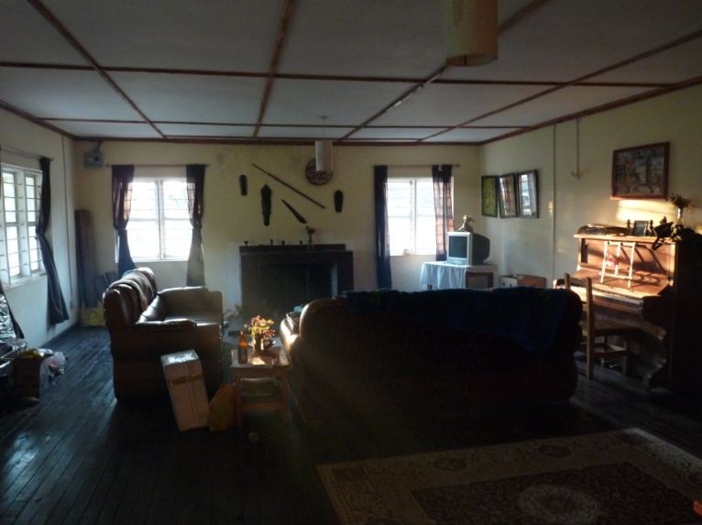
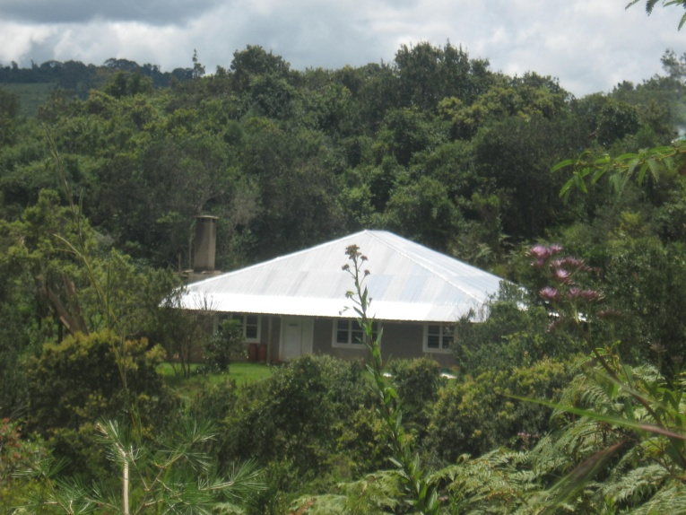
VOLUNTEER HOUSING

Included in the volunteer cost is food and housing. NOTE: We require all new volunteers who are staying past 1 month, to do a two-week stay in a Children’s House with the children of our NGO. We believe this is an important part of getting to know our organization and constructing an understanding of the lifestyle here, as well as building relationships with our children and employees. Accommodations in the Children’s Houses include a room (possibly shared depending on the number of other volunteers currently working) with a single bed and shared bathrooms with bucket baths. Meals will be traditional: ugali, greens, and beans. Bread and tea are common breakfast items in the children’s houses.
The food is typically Western in style and the volunteer housing is cement and brick walls, wood floors, and ceiling board with a tin roof. Please mention any specific dietary concerns or restrictions in the Food/Lodging Form (including vegetarianism, allergies, etc.). The accommodations are modern – running water (warm!), Western toilet, and electricity by generator. Compared to other places in the region, we consider our amenities to be fairly reliable. However, because we rely on a generator, occasionally maintenance issues do cause us to lose power or running water, sometimes for a few days at a time. We do our best to fix all maintenance issues in a timely manner. The only means to contact home are limited phone and internet services. A phone can be purchased in town cheaply ($40) and usage vouchers are available everywhere, thus communication to home and people in the region is easy. Even if you do not purchase airtime vouchers, n phone with an activated Tanzanian sim card will be able to accept calls or texts without cost to you. Internet access is limited to Tuesday through Saturday from 9 pm to 11 pm, located in our Treehouse Café! We only permit access to the internet through our provided volunteer computers and sign-ups for these computers are located inside the Café!

LIVING IN A HOMESTAY
Some of our volunteers choose to do a Homestay as part of their volunteer work. There are MANY advantages to this housing option, such as closer contact with members of the community and higher rate of language acquisition. Common amenities for a Homestay include electricity, 3 meals per day, and a private bedroom with a lock on the door. Running water is NOT a common amenity in a Tanzanian household; therefore bucket baths are the expectation. Also, drinking water in the home is boiled, though rarely filtered. We recommend volunteers purchase their own bottled water for drinking/brushing teeth etc. A homestay is a great way to gain cultural understanding and adapt to rural life even faster. The families who come forward as hosts are often very eager to learn about our volunteers as well. Many even trade Kiswahili lessons for English lessons in the home! Read the account below from a current volunteer about her homestay experience:
“Choosing to do a homestay is the most enriching part of my experience. I feel way more connected to the community that I service because I live with them. My host family is so welcoming and they have done so much to make me feel at home. I have a Baba (father) and a Mama (mother), two Dada (sisters), and 5 Kaka (brothers). There is always something to do, someone to talk to, something to help out with around the home. Getting involved in the chores was a great way to spend time with my family, which means my Kiswahili is improving. My advice for future volunteers would be to ask a TON of questions. Ask where things are, ask how to prepare food, ask anything. And don’t be embarrassed just because you think it is a silly question. There are no silly questions when everything is new and different. I totally recommend for anyone who really wants the full experience.” – Molly, Volunteer of 6 months
If you are interested in a homestay, please indicate that on your Food/Lodging Form. You also have the option of choosing to do a homestay for only a portion of your stay, depending on availability in volunteer housing. You will then be contacted to confirm you housing choice and be updated on the available amenities in your home so you can be best prepared for your stay! We have included a recommended packing list for a Homestay below:
- Solar light, torch, or flashlight
- Washcloths/towels
- Sleeping bag/extra blankets or pillows
- A water pitcher for bucket bathing

LONG-TERM VOLUNTEERS
We are always in need of long-term volunteers! We consider long term volunteers to be those who want to stay 6 months or longer. We believe that the longer you are able to stay, the bigger impact you have, as it takes 4 to 6 weeks to get acclimated and find your footing. Most volunteers upon arrival start out as very dependent as everything is a learning experience at first. However, with time, you will gradually gain independence and be amazed at what you can accomplish! Currently, we are looking for long term volunteers with TEFL certification to work in local kindergarten classrooms. If this sounds like you, please let us know!

HEALTH, MEDICAL & PERSONAL SAFETY

Tips for Staying Healthy
There is little to be concerned about when staying in Igoda village in terms of health. There are local health clinics that have trained doctors and nurses in case of any illness or ailment. There are many local duka la dawa (small pharmacies) that sell a variety of medications that may be needed to alleviate most minor symptoms/sicknesses; they are all available for a very low price in the village. Any costs incurred for health care needs are the sole responsibility of the volunteer. Below is a list of common medications available:
- Ciprofloxacin and Flagyl – for stomach aches/severe diarrhea
- Panadol/Paracetamol– for headaches and fever reduction
- Doxycycline – for malaria prevention
- Coartem – for malaria treatment
- Erythromycin- for skin infections
Not available:
- Cough/cold remedies such as Nyquil or Sudafed
- Sleep aids
- Sore throat lozenges
- Tampons
- Anti-itch creams or sunscreen
- Cephelosporins
It is recommended to receive all of the vaccinations your doctor advises before arriving in Tanzania. However, malaria does not exist in Mufindi as the elevation is too high to harbor mosquitoes. Thus, mosquito nets are not necessary here. If spending any time along the way from Dar Es Salaam to Igoda village it would be a good idea to take anti-malaria pills as directed, but once in Igoda it is your choice. Be sure to bring any medication you have been prescribed for the duration of your visit. It is also recommended to always use and drink bottled or filtered water, even when brushing your teeth. In case of emergency, the volunteer pays any medical evacuation expenses. Purchasing traveler’s insurance (or confirming personal insurance plan coverage) are the responsibilities of the volunteer.
Medication
We ask all volunteers to be forthcoming about any pre-existing medical conditions, both physical and mental health. If you are taking any medication, we must know! Living in a rural community requires better preparation in case of medical emergencies. Please disclose any health issues on the Health Questionnaire, including food or medication allergies.
Personal Safety
Guards on duty protect the volunteer housing 24 hours a day. The people of Igoda are very kind and welcoming; there is no civil or tribal unrest. As when traveling anywhere, it is always recommended to be cautious and use common sense. For example, never walk at night alone, keep your valuables close at hand, make sure to always lock windows and doors when you leave, etc. Mufindi is a very safe place with minimal crime of any type.

WHAT TO DO IN AN EMERGENCY
Volunteers should never hesitate to contact management in case of any emergency. Please see our Emergency Tree below for your personal reference. All volunteers will get a copy of this contact list upon arrival. We recommend copying it and keeping a separate copy in a safe place.

*Please note: Dr. Leena is not on-site from April to October of every year.

BEHAVIORAL CONTRACT
We hold our volunteers to the highest standards with regards to behavior. We expect all of our volunteers to be polite, respectful, and flexible. Keep in mind that as a volunteer, you are not only representing our organization, but your home country as well! We also request all of our volunteers sign a behavior contract in their introductory meeting after arrival. The content of this contract is outlined below.

Standards of Behavior
- Work cooperatively with all youth, families, volunteers, employees of Foxes’ NGO, and all others in a courteous, respectful manner, demonstrating behaviors appropriate for a positive role model for youth and the community.
- Provide a safe environment; do not harm youth or adults in any way, whether through sexual harassment, physical force, mental abuse, or any other neglectful behavior.
- Obey the laws of the locality, state, and nation.
- Strive to be a positive role model for the community.
- Participate in meetings/volunteer trainings as appropriate to duties willingly and with a positive attitude.

Attitude
Life in a rural community is difficult. Though we do our best to provide reliable transportation, water, and electricity, situations do arise where we lose one, two, or all amenities. We have systems in place to fix most foreseeable issues, but we are reliant on a whole network of people in order to keep our operations running smoothly. There will be times where you may have to walk longer distances because rain has washed the roads out, or go without electricity because of a storm. We consider these problems to be a part of daily life for our community and do our best to take them in stride, and we expect our volunteers to do the same. Comparatively, our living conditions are luxurious to some members of our community and we try to remain sensitive to this. Because of this, we ask our volunteers to be flexible and maintain a positive attitude even in tough conditions.

Relationships
Intimate relationships between volunteers and between volunteers and locals are discouraged. We understand this to be a hard rule to enforce, but we expect all of our volunteers to be safe and discreet. No one is allowed in the volunteer housing except for volunteers and APPROVED guests. That being said, ALL guests, regardless of the amount of time spent on campus, must be approved by authorizing management at least 1 week prior to arrival. Short-notice guests will not be allowed on campus. No exceptions. We urgently remind our guests that the Iringa region is a 35% HIV prevalent area. The NGO is not liable for the consequences of unsafe behavior.
Smoking
Our campus is smoking-free. There is a zero tolerance policy for smoking in the volunteer houses, work spaces, or around children. If you must smoke, please do so outside in private designated areas. These will be pointed out on your tour upon arrival. Fines will be imposed for smoking inside as the clean-up for the next volunteer is very expensive.
Drinking
Drinking alcohol is only allowed in volunteer housing after your work day has been completed. Drinking before or during your shift is absolutely prohibited, and will result in expulsion from the NGO. There is no drinking in public spaces. There is no drinking with locals or employees. Please respect the cultural norms in Tanzania and remember that alcohol is reserved for parties, weddings, funerals etc. If you do intend on drinking during your stay, you may bring your own alcohol, or request beer/wine for an additional charge on your Food/Lodging Form. However, please be discreet.
Guests
We do allow short-term guests to visit volunteers on campus. However, your guest must be approved at least 1 week in advance. No exceptions. There is also a per day charge for your guest that will be discussed pending approval. No locals are allowing in volunteer housing. No exceptions.
Property Damage
Breakage and damage to the property does happen. Upon arrival and departure, each volunteer will be subject to a room inspection. If any damage occurs during a volunteer’s stay, a fine will be charged and paid before departure. Volunteers will be asked to pay a property deposit of 100,000 Tsh CASH upon arrival. If no breakage or damage to property occurs, the volunteer will receive the deposit back in full.

Key Deposit
Upon arrival, each volunteer will be expected to pay a key deposit of 50,000Tsh. When checking out, each volunteer will receive their full deposit back once the key has been returned. If a volunteer is unable to produce their key, the deposit will be kept and go towards the replacement fee.
Rule Violations
Unfortunately, violations of our rules and expectations do happen. Everyone makes mistakes and we absolutely believe in second chances. Upon the first rule infraction, a verbal warning will be issued. Upon the second rule infraction, a written warning will be issued and filed. If a third infraction occurs, the volunteer will be subject to expulsion from our organization and departure arrangements will be made. Please note, volunteers who are expelled from our organization forfeit their volunteer costs and will NOT receive a refund. Volunteers will be escorted off the premises and will be responsible for their own travel arrangements.

THE POCKET MONEY PROGRAM
We have implemented what we call the “Pocket Money Program” to help integrate our volunteers even further into the community. All long-term volunteers will be required to take part in this program. Every two weeks, volunteers will get paid a stipend of 15,000 Tsh on wage day, similar to our employees. This stipend comes from the volunteer costs paid before arrival by the volunteer. This stipend makes it easier for volunteers to pay for food/clothes/activities around the village without having to go to the ATM every so often. How this stipend is used is entirely up to the volunteer, however, we encourage volunteers to use it to become economically involved in the formal and informal life of the village. Our goal is to encourage economic interaction between volunteers and community members. Below is a list of suggestions for how to use the stipend.

- Go out to eat in a local restaurant
- Hire a taxi to Mafinga and go shopping
- Make a purchase from our sewing school
- Buy a gift for your host family or House Mama
- Go to the traveling market
- Pay a secondary school student for Kiswahili lessons
- Purchase local artwork
- Give a tip to a House Mama for washing your clothes

WHAT TO PACK…
Below is the packing list we recommend for a one month’s stay. Please review our seasonal guide below to determine weather conditions to best prepare for your stay!
Suggested Packing List:

- Sunscreen and hat for sun protection
- Prescribed medications
- Raingear (jacket, pants, boots etc.)
- Warm jacket for “winter”
- Quick drying clothes
- Culturally appropriate clothes
- Personal toiletries
- Camera
- Torch/Flashlight
- Extra blankets
- Boots
- Kiswahili Phrase Book (if needed)
- Notebook/journal/pens

Seasonal Guide:
- November-January: big rains (multiple rain showers per day, warm)
- February-April: short rains (one rain shower per day, warm days, cool nights)
- May-July: wet season (cold, muddy, misty and foggy most of the day)
- August-October: dry season (no rain, hot both day and night, dusty)

- Cold = 40° F
- Cool = 55° F
- Warm = 70° F
- Hot = 85° F

LOCAL ATTRACTIONS
Tanzania is a beautiful country and we encourage all volunteers to get out and explore! There are many local attractions that can be reached fairly easily such as Fox Farms, Iringa Town, Mafinga, and Ruaha. If you have the chance, book a safari! Go hiking! Weather permitting, the list is endless! We recommend volunteers budget for excursions outside of the village and organize trips with other volunteers. Ask around once you arrive and we are confident you will make fast friends with the other volunteers! In this handbook, we have included a list of transportation options and contact information for easy organization. We also recommend checking out some guide books and travel blogs to help.
We use registered/licensed drivers only, and as such, we have set prices per kilometer.
- By car:
  - Omari Mgorano: 0782788120
  - Carebu (van): 0784885407
  - Robert Mdede: 0764063154
  - Phillip Mgovano: 0782426843
- By motorcycle:
  - Isaya Mwila: 0688598603
  - Kibuga Fute: 0782047381

If you are looking for English-speaking taxis…
- Sele: 0755415200 or 065841529
- Onne: 0754068388

EXIT INTERVIEW & DEPARTURE
We are always sad to see our volunteers leave. However, it gives us a great opportunity to find out what our volunteers like about our organization and to collect any suggestions/recommendations they have. Therefore, we ask all our volunteers to sit down with us for an exit interview to share their favorite stories, their biggest challenges, and to impart some wisdom before they go. We also ask our volunteers to write us a short blurb about their experience here to be included in this handbook! We consider this information to be very valuable and encourage all volunteers to disclose as much as they can. Once the exit interview is complete, the volunteer can check out, complete the final step of the room inspection, and receive their property and key deposit back!

VOLUNTEER STORIES

“Volunteering at the Foxes’ NGO was my first experience in Africa of any kind. I will never have a better one. These people and this place seep into your body and soul to forever change you. I cannot even begin to give only one highlight, so I must give several: teaching adult English has been one of the most empowering moments of my life, visiting clinics in different villages has given me the true scope of the obstacles faced and the hope that is alive here, making lifelong friends with some of the villagers has been inspiring, and playing soccer with the kids of the children’s village has been exhausting in the best possible way! I recognize already that my place in this world is much larger and at the same time much smaller than I could have ever dreamed of understanding before coming here. I will be back next year.” –Annie March-April 2010 Minneapolis, Minnesota U.S.A.

“We volunteered as part of an elective project in our final year of medical school. We were driven to the orphanage in the dark and it wasn’t until the following morning that we discovered the stunning setting for this project. Through Jenny and Geoff we were immediately integrated into the community. We spent our time visiting local villages, schools, clinics and the homes of anyone who asked for help. Any spare time was spent playing with the incredibly happy children in the orphanage. The people of Mufindi are so welcoming, friendly and so desperately in need of help. This NGO is really working to address the problems caused by the HIV/AIDS epidemic in the whole community. At times it was hard but the overall experience was incredibly rewarding. We have already booked out return visit! “ – Will & Vikki August 2009 Swansea, Wales

“Hi! My name is Maria Lehti, I come from Finland. I spent 2 months in Igoda Childrens Village in Mufindi volunteering. At home, I work as a nurse in Toolo Hospital in the neuro-surgery division. In Mufindi, I worked mainly under Dr. Leena Pasanen, accompanying her on her home-based care visits as well as working in the children’s houses. The patients and cases that I encountered here are very different from those in Finland, I found myself improving professionally during the home visits as my knowledge and expertise grew. In the Childrens Village, my job included preventive teaching, including hand washing and nutritional advice. I believe that Mufindi is a worthy destination to visit and there are all kinds of volunteer opportunities to be found.”- Maria, February 2014

