Manuscript Format (Title)

Writing guidelines for articles (Subtitle)

**Author 1 (Author name style) (leave blank for review)**

Author Affiliation (Author Affiliation and email style)

Author 1 Email

**Author 2 (leave blank for review)**

Author 2 Affiliation

Author 2 Email

**Author 3 (leave blank for review)**

Author 3 Affiliation

Author 3 Email

# Abstract (Heading 1 style)

This template is a brief guide to help you to prepare your manuscript in a uniform style for the forthcoming Proceedings of the 9th Annual Symposium of Architectural Research in Finland. Manuscripts should contain an abstract with a maximum length of 200 words. Abstracts should function as an independent description of the article.

# Introduction

Optional: Type a quote from your manuscript or the summary of an interesting point. You can position the text box anywhere in the document in the left margin area. Use the Drawing Tools tabs to change the formatting of the pull quote text box. (Ingress style)

After receiving the acceptance notification, full articles (5000–8000 words without references) are to be submitted in PDF format using this Word manuscript template for layout and fonts. Submissions must be original and must not have been submitted for publication elsewhere. In order to ensure anonymity, the authors must *not* include their names and affiliations in the manuscript and refer to their own previous work in third person when possible. Please title the PDF document “Fullpaper_Authorsurname” (names will be removed before forwarding to reviewers). The authors are also asked to sign and submit the scanned copyright agreement. As the Symposium is international, all submissions must be written in English. Authors are responsible for proofreading their own manuscripts.

# Sections, references and citations

This format is to be used for manuscript submissions that will be shared during the symposium. The body text is in single-column layout.

After the Symposium, authors are invited to submit their papers to:

* Architectural Research in Finland / PTAH
* Journal of Business Models (Business Models in the Built Environment special session)
* Lighting Research and Technology (Smart Lighting special session)

The authors will be then asked to finalize their manuscripts according to the manuscript submission guidelines of each journal.

## Sections, subsections and sub-subsections (Heading 2 style)

Sections can include titles such as Introduction, Methods, Results, Conclusions and Acknowledgements (use Heading 1). You can divide your text into subsections (use Heading 2 for section title) or sub-subsections (use Heading 3 for section title).

### cid:B5380C98-F9E8-4C79-B502-0388AE893E02Fonts (Heading 3 style)

Figure 1. An example of figure placement and figure text positioning. You can place figure text in a text box adjacent to figure in the left margin. Please use 8-point Arial font for figure text with bold font in its title. (Caption style)

Please use a 10-point Arial font for body text (Normal style). Section titles are (Heading 1) are 12-point Arial font in bold, subsections titles (Heading 2) 10-point Arial in bold and sub-subsection titles (Heading 4) 10-point Arial in italics.

### References and citations

In-text citations should be written in parentheses in such a way that the name of the author is followed by the year of publication and pages of the reference if needed (Author 2016, 100-105). When referencing two or more references published by the same author on the same year, the publication should be identified with lower-case letters (Author 2016a; 2016b).

References should follow the Harvard system. Please see a full guide at: <http://libweb.anglia.ac.uk/referencing/harvard.htm>. References should be listed in full and in alphabetical order at the end of the paper. Some examples of common reference types are given at the end of this submission guideline document.

### Quotations

Figure 2. An example of figure placement and figure text positioning. You can place figure text in a text box adjacent to figure in the left margin. Please use 8-point Arial font for figure text with bold font in its title.

Short quotations should be written within the main text using “quotes marks”.

Longer quotes should be placed as their own section and they should be written in italics but without quotation marks.

## Figures and tables

Examples of figure placements are given in Figure 1, 2 and 3. Due to the versatile illustrative needs of each manuscript, several forms of figure placements are possible. However, please note that if you place a figure directly adjacent to edge of the paper, clipping may occur in possible print-outs of manuscript. Due to this reason, it is important that figure texts are located within the margin area of 1.27 cm from each side.

|  |  |  |  |
| --- | --- | --- | --- |
| In this template: | Participant 1 | Participant 2 | Participant 3 |
| Number of responses | 1 | 2 | 3 |
| Number of responses | 1 | 2 | 3 |
| Number of responses | 1 | 2 | 3 |

Table 1. An example of table placement and figure text positioning, (Caption style)

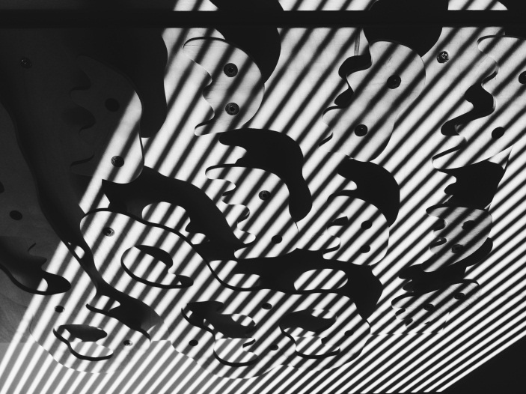Leave the footer area free of illustrations at the bottom of each page. The manuscripts will be submitted and published online as PDF-documents. Please note that authors are responsible for placing the figures in the layout and ensuring that they are of good quality. Therefore use resolution of minimum of 300 dpi for bitmap based files (such as .tif or .jpeg files and resolution of 600 dpi for line art files (such as .eps files). Both color and greyscale figures can be used. Using Wrap text – Top and bottom option and different Position options available under Format menu in Picture tools may be helpful when positioning the figure to desired place.

Both figures and tables should be accompanied by a title below each figure or table. Both figures and tables should be referred to in the body text. Please use 8-point Arial font in bold for both figure and table title texts. We suggest that you use 8-point Arial font for table texts and place the title of the table in format of **Table 1.** If applicable, place the table within the 1-column area but if necessary, the left margin area can be used as well.

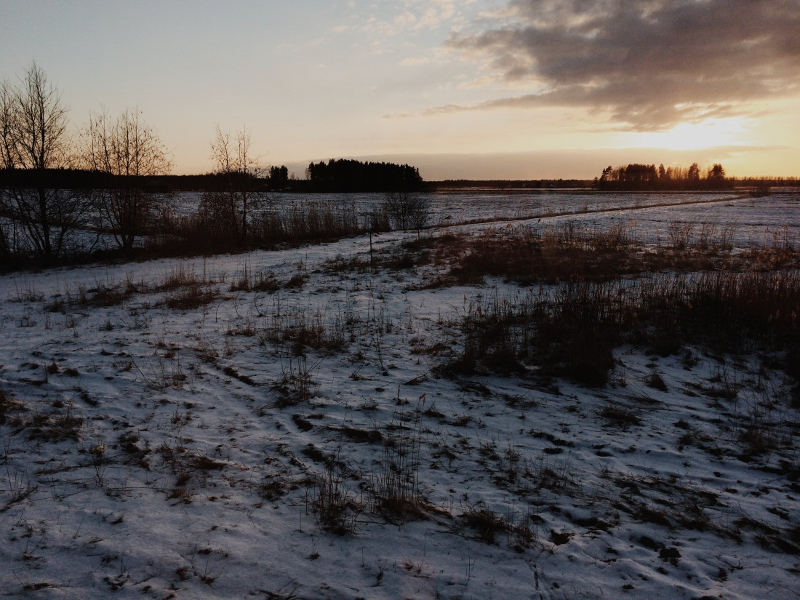

Type a quote from your manuscript or the summary of an interesting point. You can position the text box anywhere in the document in the left margin area. Use the Drawing Tools tabs to change the formatting of the pull quote text box.

Figure 3. An example of figure placement and figure text positioning. You can place figure text in the body text below the figure. Please use 8-point Arial font for figure text with bold font in its title.

# Acknowledgements

Authors may acknowledge contributions to the presented research or credit illustrations here. Also authors may provide information in this section on how the research is funded, for example through research foundation, university, authority, organization or spare time research.

# References

References should follow the Harvard system, please see a full guide at http://libweb.anglia.ac.uk/referencing/harvard.htm. References should be listed in full and in alphabetical order at the end of the paper. Examples of referencing books (Ridley 2012), journal articles (Keitch 2012), edited books (Samson 1970) and online sources (V&A Museum 2015) are given below.

Keitsch, M., 2012. Sustainable architecture: design and housing. Sustainable Development, 20(3) pp. 141-145.

Ridley, D., 2012. The literature review: a step-by-step guide for students. 2nd ed. London: SAGE.

Samson, C., 1970. Problems of information studies in history. In: S. Stone, ed. 1980. Humanities information research. Sheffield: CRUS. pp.44-68.

V&A Museum, 2015. Introduction to English embroidery. [online] Available at: [Accessed 8 August 2016].