

Manuscript Format – Title

Writing guidelines for full papers – Subtitle

No identifiers in the manuscript before finishing the double-blind review process

**Author 1 Affiliation / Author 1 Email**

**Author 2 Affiliation** **/ Author 2 Email**

## Abstract

This template is a guide to help you to prepare a manuscript in a uniform style for ATUT2020 proceedings that will be published in the online journal *Architectural Research in Finland* [https://journal.fi/architecturalresearchfinland/ about](https://journal.fi/architecturalresearchfinland/%20about). The manuscript should contain an abstract with a maximum length of 500 words. An abstract should function as an independent description of the manuscript and you should refer to it as a paper or article (instead of a presentation). Please, note that organizers will publish the abstracts in the Book of Abstracts, which will be available (but not publicly downloadable) at the symposium.

**Keywords:** keyword, keyword, etc.

## Introduction

Full papers (6000–8000 words without references) for ATUT2020 (symposium Day 2) will be submitted to [atut.oulu@gmail.com](mailto:atut.oulu@gmail.com) in Word format using this template for layout and fonts. After the symposium, the manuscript will be elaborated further by utilizing the received feedback and re-submitted to [atut.oulu@gmail.com](mailto:atut.oulu@gmail.com) for double-blind review process. Submissions must be original and must not have been submitted for publication elsewhere. Each manuscript will be reviewed by two referees under a double-blind review process where the authors and the reviewers are kept anonymous. In order to ensure anonymity, the authors must remove their names and affiliations from the front page of template, file’s meta information and refer to their own previous work in third person. Please title the Word document “Fullpaper_Authorsurname” (names will be removed before forwarding the file to reviewers). The manuscript language is English.

*Type a quote from your manuscript or the summary of an interesting point. You can position the text box anywhere in the document in the left margin area. Use the Drawing Tools tabs to change the formatting of the pull quote text box.*

## Sections, references and citations (Heading 2)

This format is to be used for submissions that are published in the forthcoming online journal. The body text is in single-column layout.

### Sections, subsections and sub-subsections (Heading 3)

Sections can include titles such as Introduction, Methods, Results, Conclusions and Acknowledgements (use Heading 2). Also, you can divide your text into subsections (use Heading 3 for title) or sub-subsections (use Heading 4 for title).

#### Fonts (Heading 4)

Please use a 10-point Arial font for body text. Sections titles are (Heading 2) are 14-point Arial font in bold, subsections titles (Heading 3) 10-point Arial in bold and sub-subsection titles (Heading 4) 10-point Arial in italics.

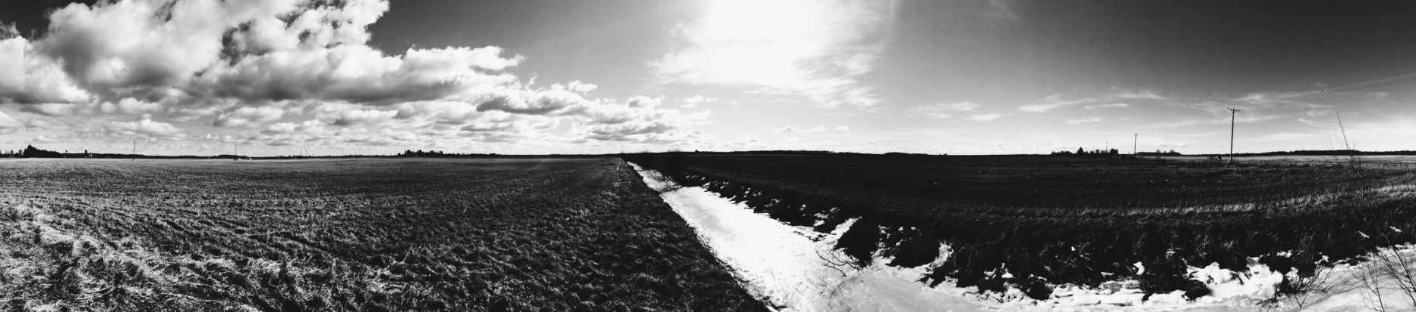

### References and citations

**Figure 1. An example of figure placement and figure text positioning.** You can place figure text in a text box adjacent to figure in the left margin. Please use 8-point Arial font for figure text with bold font in its title.

In-text citations should be written in parentheses in such a way that the name of the author is followed by the year of publication (Cormack, 1994) and pages of the reference if needed (Cormack, 1994, pp. 124-125). If two or more references are published by the same author, they should be sorted with a semicolon (Patel, 1992; 1994). If two or more references are published by the same author on the same year, the publication should be sorted with lower-case letters (Bloggs, 1993a; 1993b). References should follow the Harvard system, please see a full guide at: <http://libweb.anglia.ac.uk/referencing/harvard.htm> References should be listed in full and alphabetical order at the end of the manuscript. Examples of references are given at the end of this submission guideline document.

### Quotations

The short quotations from other authors’ works should be written in the text using quotes. Longer quotes should be placed as their own section moved slightly into the margin of the column and they should be written in italics but without quotation marks.

**Figure 2. An example of figure placement and figure text positioning.** You can place figure text in a text box adjacent to figure in the left margin. Please use 8-point Arial font for figure text with bold font in its title.

### Annotations

If you need to use annotations, put them in the footnotes, and mark them using Arabic numbers (1, 2,3…), and use 8-point Arial in the text.[1]

## Figures and tables

The author(s) is responsible for image rights, and all photos/images shall have references. 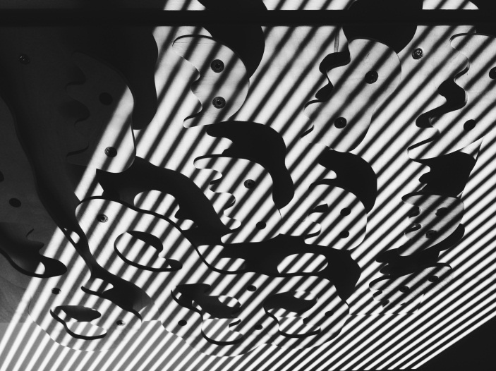Examples of figure placements are given in Figure 1, 2 and 3. Due to versatile illustrative needs of each manuscript, several forms of figure placements are possible. However, please do notice that if you place a figure directly adjacent to edge of the paper, clipping may occur in print-outs of published papers depending of the printer. Due to this reason, it is important that figure texts are located within the margin area of 1.27 cm from each side. In addition, leave the footer area free of illustrations at the bottom of each page. The accepted and finished manuscripts will be submitted and published online as PDF-documents. Please note that authors are responsible for placing the figures in the layout and ensuring that they are of good quality. Therefore use resolution of minimum of 300 dpi for bitmap based files (such as .tif or .jpeg files and resolution of 600 dpi for line art files (such as .eps files). Both color and greyscale figures can be used. Using Wrap text – Top and bottom option and different Position options available under Format menu in Picture tools may be helpful when positioning the figure to desired place.

Both figures and tables should be accompanied by a title and they should be referred to in the body text. Please use 8-point Arial font for figure text with bold font in its title. We suggest that you use 8-point Arial font for table texts and place the title of the table in format of **Table 1. Title** above the tables in 8-point Arial in bold. If applicable, place the table within the 1-column area but if necessary, the left margin area can be used as well.

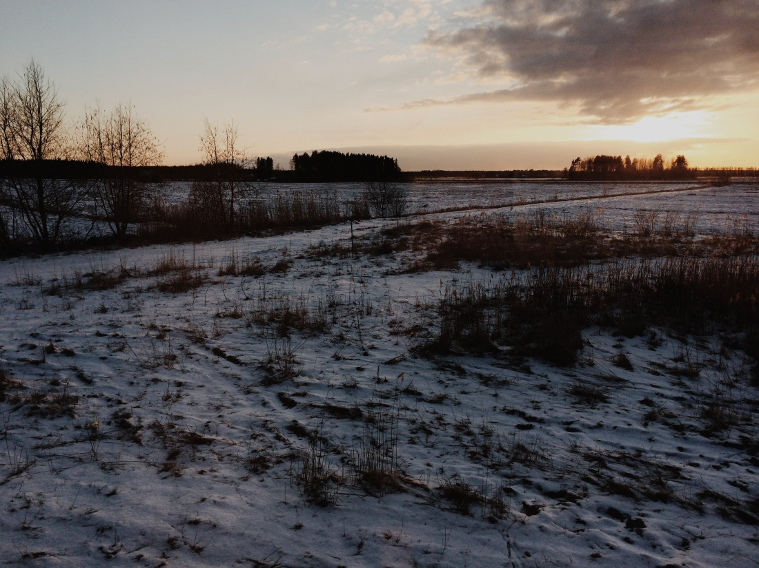

**Figure 3. An example of figure placement and figure text positioning.** You can place figure text in the body text below the figure. Please use 8-point Arial font for figure text with bold font in its title.

## Acknowledgements (No identifiers in the manuscript before finishing the double-blind review process)

Authors may acknowledge contributions to the presented research or credit illustrations here. Also authors may provide information in this section on how the research has been funded, for example through research foundation, university, authority, organization or spare time research.

## References (No identifiers in the manuscript before finishing the double-blind review process)

References should follow the Harvard system, **please see a full guide at:** <http://libweb.anglia.ac.uk/referencing/harvard.htm> References should be listed in full and in alphabetical order at the end of the manuscript. Examples of references are given below.

Books:

Barker, R., Kirk, J. and Munday, R.J., 1988. *Narrative analysis*. 3rd ed.

Bloomington: Indiana University Press.

Silverman, D.F. and Propp, K.K. eds., 1990. *The active interview.* Beverly Hills, CA: Sage.

Chapters of edited books:

Samson, C., 1970. Problems of information studies in history. In: S. Stone, ed. 1980. *Humanities information research*. Sheffield: CRUS. pp.44-68.

Journal articles from printed sources:

Boughton, J.M., 2002. The Bretton Woods proposal: a brief look. *Political Science Quarterly*, 42(6), p.564.

Articles publically available on the internet:

Kipper, D., 2008. Japan's new dawn. *Popular Science and Technology*, [online] Available at: <http://www.popsci.com/popsci37b144110vgn/html> [Accessed 22 June 2009].

Articles with DOIs

Boon, S., Johnston, B. and Webber, S., 2007. A phenomenographic study of English faculty's conceptions of information literacy. *Journal of Documentation*, [e-journal] 63(2), pp.204 - 228. http://dx.doi.org/10.1108/00220410710737187.

**Copyright agreement**

After the double-blind review process, the authors of accepted manuscripts will be asked to sign and submit a copyright agreement for the Architectural Research in Finland journal. Before publishing, the authors of accepted manuscripts are responsible for having their manuscripts proofread by a native speaker.

1. If you need to use annotations, put them in the footnotes, and mark them using Arabic numbers (1, 2,3…), and use 8-point Arial in the text.